Sunday | Monday | Tuesday | Wednesday | Thursday | Friday | Saturday
 |  |  |  |  |  | 1
2 | 3 | 4 | 5 | 6 | 7 | 8
9 | 10 | 11  Shavuot Begins | 12 | 13 | 14  Flag Day (US) | 15
16  Father’s Day | 17 | 18 | 19  Juneteenth | 20  Summer Begins | 21 | 22
23 | 24 | 25 | 26 | 27 | 28 | 29
30

30 MINUTES OF FUN AND FITNESS OFFERED DAILY!

 | GOLF  ICE CREAM FACTS  REMINISCING  ICE CREAM POT CRAFT  CATEGORIES | SANDBAGS  SUMMER FOOD/DRINK  REMINISCING  BEE CRAFT  FAMILY FEUD | CHAIR SOCCER  LET’S TALK DANCE  REMINISCING  DANCE CRAFT  BINGO | CHAIR SOCCER  LET’S TALK DANCE  REMINISCING  DANCE CRAFT  BINGO | AXE THROWING  QUESTIONS TO MAKE YOU THINK  DISCUSSION  BOARDGAME  MIN TO WIN IT
 | BOWLING  BBQ FACTS  REMINISCING  WATERMELON CRAFT  GAME OF 3’S | RING TOSS  MOON FACTS  DISCUSSION  MOON CRAFT  BINGO | AXE THROWING  FISHING FACTS  REMINISCING  FISH CRAFT  A-Z | AXE THROWING  FISHING FACTS  REMINISCING  FISH CRAFT  A-Z | LADDERBALL  VINYL FACTS  DISCUSSION  BUTTERFLY CRAFT  WORD IN A WORD
 | AXE THROWING  DAD FACTS  DAD QUOTES  TIE KEYRING CRAFT  BINGO | DARTS  ROSE FACTS  DISCUSSION  COLORING PAGE  CATEGORIES | BALLOON BADMINTON  JUNE FACTS  DISCUSSION  FLOWER CRAFT  MIN TO WIN IT | BALLOON BADMINTON  JUNE FACTS  DISCUSSION  FLOWER CRAFT  MIN TO WIN IT | CHAIR SOCCER  INSTRUMENT FACTS  DISCUSSION / MUSIC  WINDCHIME  GAME OF 3’S
 | CHAIR SOCCER  MOON FACTS  DISCUSSION  MOON CRAFT  MIN TO WIN IT | AXE THROWING  BICYCLE HISTORY  DISCUSSION  BICYCLE CRAFT  WORD IN A WORD | SANDBAGS  THIS & THAT / MAD LIBS  REMINISCING  NO SEW CRAFT  GAME OF 3’S | SANDBAGS  THIS & THAT / MAD LIBS  REMINISCING  NO SEW CRAFT  GAME OF 3’S | BOWLING  STAMP FACTS  DISCUSSION  STAMP CRAFT  BINGO
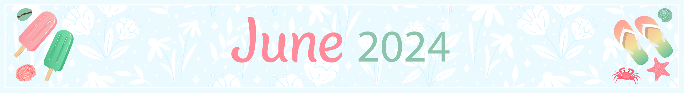
ALZHEIMER’S SOCIETY OF CORNWALL AND DISTRICT – ADULT DAY PROGRAM – 1-888-222-1445 OR 613-361-2391 (NICOLE)

