BOB & ISABEL GOLF FOR ALZHEIMER’S TOURNAMENT
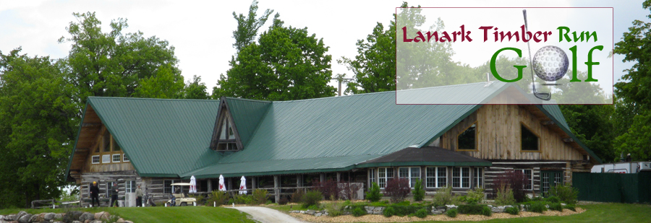
Saturday July 17, 2021
We are pleased to offer a variety of sponsorship/partnership opportunities that include visibility and valuable benefits designed to meet your community support and marketing objectives.
2021 Sponsorship Opportunities

Platinum Sponsor $2,000
- Includes 4 tickets
- Recognition as presenting sponsor
- Logo on all Golf Carts
- Principal Logo positioning on all promotional materials
- Hole Sponsorship
- Logo and link to your website on our website
- Opportunity to showcase your company and highlight your products or services on social media post. Can either be a video or post with pictures.
- Recognition in Alzheimer Society Lanark Leeds Grenville newsletter
- Inclusion in a minimum of 4 social media posts
- Charitable tax receipt for $1,125.00
Gold Sponsor $1,500
- Includes 4 tickets
- Prominent logo positioning on all promotional materials
- Hole Sponsorship
- Logo and link to your website on our website
- Recognition in Alzheimer Society Lanark Leeds Grenville newsletter
- Inclusion in a minimum of 2 social media posts
- Charitable tax receipt for $625.00

Silver Sponsor $1,000
- Includes 2 tickets,
- Logo on all Promotional materials
- Hole Sponsorship
- Logo and link to your website on our website
- Recognition in Alzheimer Society Lanark Leeds Grenville newsletter
- Inclusion in a minimum of 1 social media post
- Charitable tax receipt for $425.00

If you are sponsoring at any of the levels above we welcome you to join us on the hole you will be sponsoring to promote your business or play a game for prizes or give out promotional items or treats to our participants. Please indicate this if you would like to take advantage of that opportunity.
( ) Yes I will be attending and will have representatives promoting on the course the day of the event
*We have a second tentative date of Friday September 10, 2021 for an additional tournament. If we go ahead with this, we will advertise your signs the day of that event as well.
Hole Sponsorship

- $125.00 Your name will be displayed on the course the day of the event.
- We will announce your participation/support in our newsletter

Other Opportunities
Live/Silent Auction Donor
Item Description:_________________________ Value: ___________________
A tax receipt will be issued for the full retail value of the item.
I would like to donate items for Take Away Bags (144 items needed)
Item Descrition: _________________________ Value: ______________

Impact of Your Sponsorship
There are currently 564,000 Canadians living with Dementia.
Approximately 4,000 live in Lanark Leeds Grenville
Each year there are 25,000 new cases diagnosed. That’s 480 people per week
Dementia is the 3rd leading cause of death in Canada and there is no treatment or cure.
Your sponsorship means families have access to programs and services that allows them to live well with dementia and remain active members of our community.
During Covid we have altered out programs to be offered virtually and have provided families with iPads to access these services if needed. They need our support now more than ever to reduce the impact of social isolation.
Some Services we Provide
Support
Provides a safe, caring environment for individuals affected by Alzheimer disease and related dementia to connect, share and learn more about the disease and how to better understand the changes that they may be experiencing.
First Link
Gives persons with dementia, their care partners and family a direct connection to a wide variety of services and supports.

Education
Provides awareness and educational opportunities for family caregivers, children, professional health care providers, community organizations, as well as the general public.
Minds In Motion
A social program that incorporates physical activity and mental stimulation for people with early to mid-stage signs of Alzheimer’s disease or other dementias and their care partners.

Adult Day Program
A social program for individuals with Alzheimer's disease or related dementia and the frail elderly. The goal is to provide socialization and support for individuals who reside at home while providing the caregiver with respite relief. We currently operate 12 programs weekly.
Overnight Staycare
We offer 3 beds per weekend in a safe and comfortable homelike environment.
This program provides a mix of social, cognitive and other related support services for the person with dementia and provides extended respite relief for caregivers.

Company: ___________________________________________________________
Contact: ________________________________________
Mailing Address: ______________________________________________________
___________________________________________________________________
Email Address: _______________________________________________________
Phone: _________________________________________

Please charge my Credit Card in the amount of: __________________
Card Number: ______________________________________
Expiry Date: _______________________ 3 Digit Code: _____
Signature: ________________________________________

Please make cheques payable to: Alzheimer Society Lanark Leeds Grenville
115 Christie Lake Rd. Perth, ON K7H 3C6
Questions or Information contact:
Bobbi-Jo White, Fund Development & Marketing Coordinator
Email: bwhite@alzllg.ca
Phone: 613-345-7392 or 866-576-8556

