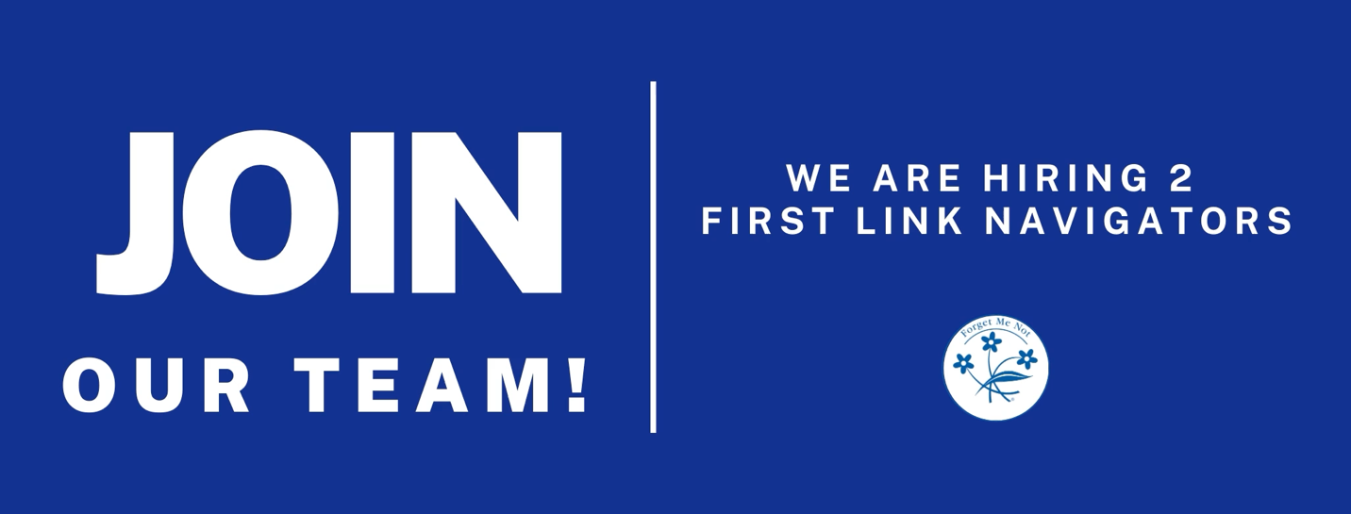

First Link Navigator – West

First Link Navigator – East
Salary: Based on Qualifications and Experience + Benefits after successful review
Ending Alzheimer’s disease is one of the greatest causes of our time – and it demands great people. Many of us who work for the Alzheimer Society have some connection with Alzheimer’s disease or another form of dementia. It is what drives and motivates us in our efforts to fight against a disease that currently has no cure.
The Alzheimer Society is a volunteer-based, non-profit organization committed to improving the lives of people affected by Alzheimer’s disease and related dementias. Alzheimer PEI is currently recruiting an ambitious and result-oriented individual to work as a permanent full-time First Link Navigator (FLN) based in Eastern and Western Regions of PEI.
Job Summary
The First Link Navigator (East/West) will coordinate and integrate supports and services around the person living with dementia and their care partner. In this direct client service role, they will be the key “go-to” person for families after a dementia diagnosis, with responsibility for identifying needs, supporting self-management goals, and strengthening the communication and care planning linkages between providers and across sectors along the continuum of care. The First Link Navigator will strive to ensure that every person diagnosed with dementia and their care partners have timely access to information, learning opportunities and support when and where they need it in order to achieve the following outcomes:
- increase system capacity to provide families facing a dementia diagnosis with system navigation support
- improved client experience and health for the person with dementia and their care partner(s)
- greater care partner capacity and competency to effectively manage their role and reduce incidence of crisis situations
- enhanced capacity for the person living with dementia to remain in their own home and community for as long as possible
Essential Duties and Responsibilities
Initial Contact, Assessment and Care Planning:
- Pro-actively manage incoming First Link direct referrals to facilitate early intervention and ensure that clients (people living with dementia and their care partners) have a named point of contact for care navigation support as early as possible before and/or after diagnosis
- Gather information, conduct or review relevant assessments, and meet with clients (people living with dementia and care partners) to identify current and future needs, goals and level of risk.
- Establish appropriate intervention plans with internal and external resource matching to meet bio/psycho/social needs using a person/family-centred approach
- Identify needs related to care coordination across service providers and outline responsibilities of all parties
Navigation and Care Coordination:
- Support clients in navigating the system to access appropriate learning opportunities, support services, care and resources as identified in their individualized plan of service
- Pro-actively facilitate and advocate for linkages, communication, information exchange and coordination between clients and service providers along the continuum of care
- Facilitate regular and ongoing care conferences between clients/care partners and all members of client/care partner care team. This may include in-person meetings and use of a range of technology options and/or accommodations, including Video Conferencing, Zoom, Teleconference, etc.
- In collaboration with internal and external parties, engage in problem solving and develop strategies to address/overcome barriers in effective coordination/integration of supports and services
- Leverage and maintain positive working relationships with physicians, health care professionals, health and community support service providers (e.g. hospitals, primary care, mental health, long-term care, retirement homes, police/EMS, specialized geriatrics), and other relevant partners through proactive outreach activities
- Support awareness of First Link to health professionals, service providers and other relevant community stakeholders in collaboration with internal and external partners
Pro-active Follow-Up:
- Monitor and provide proactive follow-up for clients and care partners to ensure ongoing collaboration across services/providers and to identify opportunities for new or emerging care options to meet changing needs and to address service/support gaps
- Provide supports to clients and care partners as they transition through use of different parts of the health, social and residential care / Long Term Care systems
Monitoring/Evaluation:
- Collect, maintain and report required quantitative and qualitative data to support province-wide monitoring, evaluation and reporting
- In collaboration with the Alzheimer Society, participate in planning and implementation of evaluation to examine the overall effectiveness of First Link referral, intake, navigation, care coordination, and proactive follow-up functions, to ensure a timely response to emerging needs
Service Delivery Standards and Quality Improvement:
- Maintain confidential, accurate and current client records, including complete and thorough documentation for each client contact, in compliance with relevant privacy legislation and in accordance with professional standards and internal policies
- Ensure that client consents, privacy, and confidentiality are maintained in compliance with legislation, professional standards/regulations and internal policies
- Maintain an advanced level of knowledge of Alzheimer’s disease and other dementias, including clinical manifestations, behaviours, current care practices, treatment options, placement options, available community resources, and all relevant legislation
- Assist with the development and maintenance of policies, procedures and resources to support First Link referrals, intake, system navigation, care coordination, and follow-up activities.
Job Qualifications
Education:
- Minimum bachelor’s degree in social work, Master’s level education or working towards the same preferred. Presently Registered with PEI Association of Social Workers or pending Professional Registration.
Experience:
- Minimum 5 years client service experience in the health and/or social service sectors
- Experience working directly with people living with Alzheimer’s disease or other dementias and their care partners
- Experience and knowledge in management of chronic and complex health conditions
- Knowledge of available community services/supports and clinical, social and residential care options
- Understanding of roles and linkages across primary care, community care and specialized geriatric services
- Strong knowledge of client-centred philosophy
- Knowledge of clinical practices and training models related to dementia (e.g.: Positive Approach to Care (Teepa Snow), P.I.E.C.E.S. and U-First!)
- Experience in assessment and care planning/coordination
- Experience working in settings requiring inter-professional collaboration
Other Knowledge, Skills, Abilities or Certifications:
- Excellent communication (verbal and written)
- Exceptional interpersonal skills, including shared decision-making and facilitation
- Ability to prioritize workload and manage competing tasks
- Ability to take initiative and be resourceful
- Excellent problem-solving and change management skills
- Proficiency in technology (e.g.: ALL Microsoft office, eTapestry or cloud-based case management and care coordination systems)
- Demonstrated ability to work independently and within a team
- Expertise and experience in cultural sensitivity and diversity

Travel Requirements:
- This position involves travel to communities East or West following the Alzheimer Society travel policy. This position requires a valid driver’s license with a clean driver’s abstract.
Please submit your resume and cover letter with subject line First Link to:
Society@alzpei.ca
We thank all who apply, but only those selected for an interview will be contacted.
Job Type: Part-time / Full-time
Experience:
- Client Services: 5 years (Preferred)
Education:
- Bachelor's Degree (Preferred)

