Picture It

Double Exposure
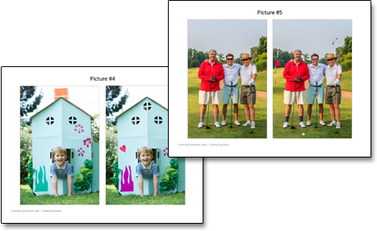

Here are double prints of what looks like the same picture. However, if you look closely, there are five things that are missing or have been changed in the second print.

How to use the pictures:
- Print the pictures and circle the differences between the two. Or point at your screen and look for 5 differences.

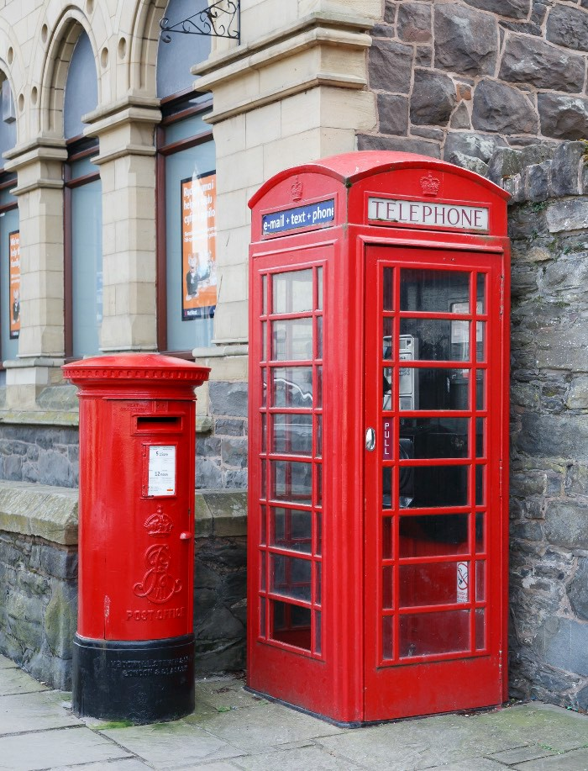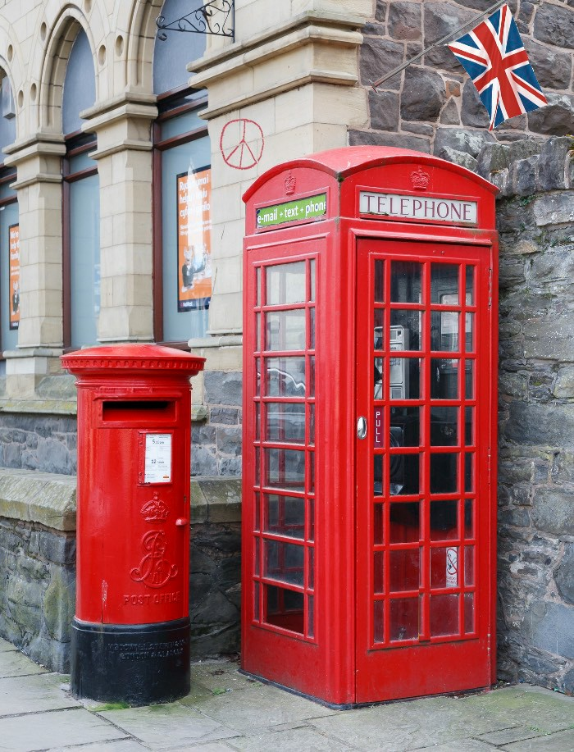

Double Exposure
(solution)

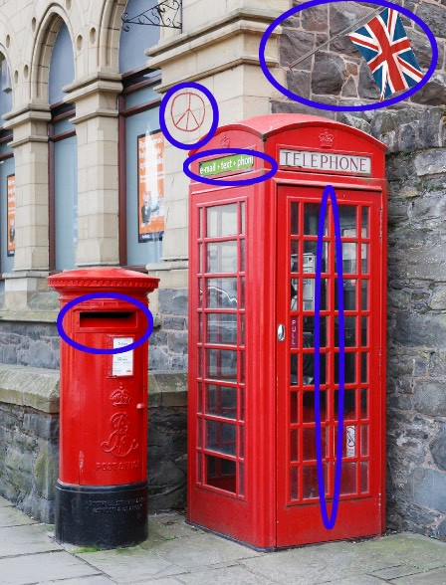Picture
  - There is a British flag on the building.
  - There is a peace symbol on the bricks.
  - The blue sign on the phone booth is now green.
  - There is an extra bar on the phone booth.
  - The mail slot is larger.

