First Link Electronic Form Submission Tip Sheet
Initial setup/use
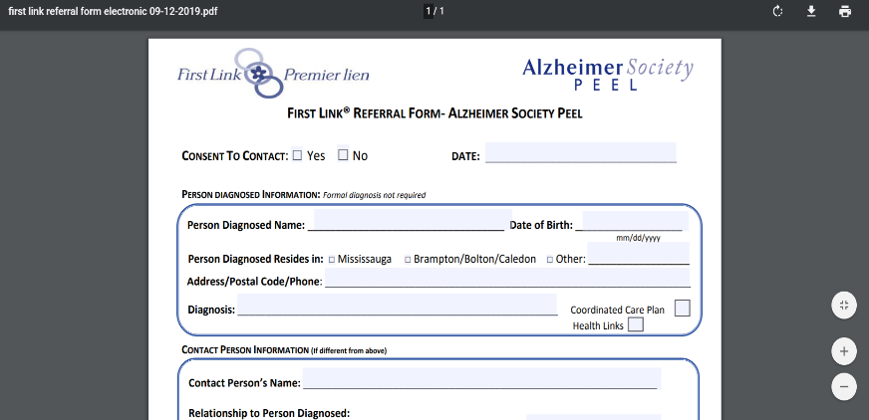
- Download the form
- Save to your desktop or other directory
- Retrieve saved form
- Fill out the form
- Click submit
- Allow Adobe to access your Email Account
- Click Send
- Close any Drafts that may be open

Subsequent Use

- Next time send directly from your saved form
  - Retrieved saved form
  - Fill out the form
  - Save your completed form
  - Click submit
  - Click send
  - Close any Drafts that may be open

