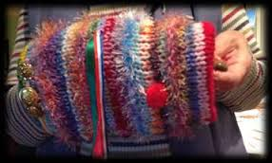
Twiddlemuffs

How to support people with dementia by
Knitting a basic hand muff

Do you knit? Have you heard of
Twiddlemuffs?

They are a knitted muff with items securely attached so that a person with dementia can twiddle in their hands. People with dementia often have restless hands and like to have something to keep their hands occupied. It provides a wonderful source of visual, tactile and sensory stimulation while also keeping hands snug and warm.

We are hoping that volunteers will come forward and put their knitting skills to good use and help create Twiddlemuffs! The soft knitted muffs contain strands of textured ribbon, beads, buttons and various fabrics both inside and out.

Patterns are available at our office or we can send to you via email.

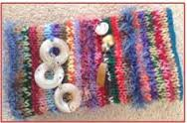
Please contact us at: info@alzheimersarnia.ca or drop by the office at 420 East Street N., Sarnia
We can be reached by calling 519 332 4444

If you cannot knit but would like to contribute to this project, donations of wool, and decorations (buttons, beads, ribbons, pom poms would be gratefully appreciated!

With grateful thanks to Warrington & Halton Hospitals, England whose idea we have “pinched with pride”.

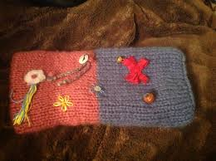
Twiddlemuff instructions

Materials

- This muff pattern is perfect for using left over and
odd balls of wool
- Needles: 8mm circular or 6.5mm straight

Directions

Cuff: Cast on 45 stitches using 2 strands of DK wool or
1 strand of chunky (one plain colour works best)
Work in stocking stitch (K a row, P a row) for 11 inches

Muff Body: Continue with SS but use various textures of wool (chunky, mohair, ribbon etc.) until the work measures 23 inches (two strands of DK for two rows each gives a good assortment of colours)
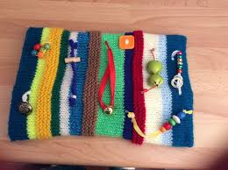
Cast off.

Finishing

- If using straight needles, lightly iron the strip
then neatly join the sides together using edg
to edge stitch (RS out)
- Turn inside out and push the one colour cuff
up inside the muff body
- Sew the two ends together using a neat edge

Decoration

Now is the time to decorate the muff (inside and out) with ribbons, beads, flowers, buttons…wherever your imagination takes you!
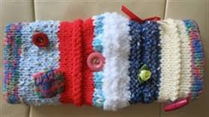
Be creative but please be sure each item is securely attached

